HOTEL RESERVATION DATASET
Deepshi Sachan
Webster University
CSDA 5110: Analytics Programming with R
Professor Yogi Talakanti
March 4, 2023

EXECUTIVE SUMMARY
The objective of this report is to answer several questions from hotel reservation datasets which is used for data analysis. Using classification method, I will build logistics regression model to predict whether hotel booking will get cancel or not and what factors lead to cancellation of hotel reservations.
DEFINITION
Hotel Reservation datasets contains different attributes of customers’ reservation details. This dataset contains information like type of room reserved, meals selected, no. of guest made reservation, number of days customer stays in hotel, lead time, average price per day of the reservation made, peak time-period of the year when booking is made, etc. and from these variables we are going to predict whether customer will cancel their booking or not. The purpose of this was to see if there are any possible trends that could correlate the variables with chances of getting reservation canceled and build a model that fits well with highest accuracy.
PREPARATION
I gathered “Hotel Reservations” dataset from Kaggle.com site which I have uploaded in RStudio to perform various statistical analysis on the dataset. To gain further insight from the data, I plotted several charts using R to find how each variable are distributed. I will find correlation of different variables with booking status, like the chances of getting reservation canceled, how much time did guests stay in and at what time of year, from which platforms hotel rooms are booked more often. Using the dim () function in R, I was able to see that there are a total of 36725 observations and 19 columns. Using String command, I have figured out the data structure and data type of each column.
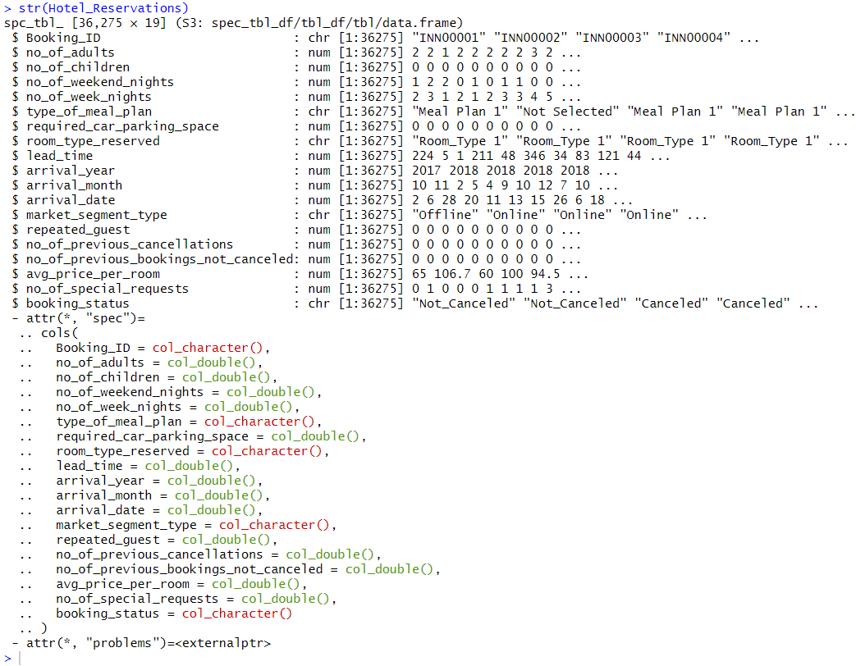
Then I have checked for null and missing data using map () function and found that there are no NAs in each column of dataset. I have converted dependent outcome variable booking status from categorical to numerical variable (Cancelled = 1, Not_Cancelled = 0) using ifelse command to fit the regression model and to find correlation using corr plot. Here I will remove booking Id variable that will not be used while building model. For fitting model, I have prepared Train and Test dataset in the ratio of 70:30.
With the help of ggplot, I plotted graph that shows data distribution of each variable. From it, I found that most reservations are made for rooms with two adults and no children, most reservations are short-term and rarely are long-term, most reservations choose meal plan 1, that most reservations do not require a parking space, that the most popular room types are types 1 and 4, and that much of our data pertains to bookings from 2018. When we look at the bookings by month, we can see that there is an increase. From Jan to Oct, the number of bookings gradually increases, and it then decreases again in the months of Nov and Dec. Most bookings are made online, and most of the guests are first-time visitors who typically do not cancel. We have about 67% of reservations that haven't been canceled, as seen when we check at our goal variable. Looking at our continuous variables, I can see that, in general, reservations are made quickly; the longer it takes, the less reservations there are. Peak of our data typically occurs at $100, which is the average hotel cost.
From this we can analyze there is no strong correlation between different variables.

DATA ANALYSIS
My preliminary findings revealed that there is no strong correlation between different variables, so I am going to do bivariate analysis to find how booking status is related with each variable using ggplot facet_wrap () function. Below chart- No. of adults vs Booking status. Ratio of booking got canceled vs not canceled is higher for 2 or more adults when compared to 1 adult.
Here, we can see that average price per room ranges from 0 to 300 dollar. And most of them were of 100 dollars.
This tells that people who have special request are less likely to cancel booking.
Chances of canceling the reservations is likely less in offline booking (ratio is 20:9).
Although the data for Year 2017 is less but the ratio of cancelling the reservation is low in 2017 when compared with year 2018. Most of our data pertains to bookings from 2018 and when we break down the bookings by month, we can see that there is an upward trend. From February to October, the number of bookings progressively increases, and it then starts to decline again in the months of November, December, January.
Most reservations do not require a parking space. Only 3% requested for parking space.
This plot tells us that the Reservation that took less lead time are likely to not cancel booking.
Here, Cancelled= 1, Not Cancelled= 0.
Using boxplot, I was able to spot the outliers in lead time and average price per room variables which I have eliminated while data preparation.

Figure 1
Based on the statistical information in Figure 1 we can see that there is significant
correlation among different variable with booking status since p < .0000002. Then took sample from hotel reservation dataset and used 70% of dataset as training set and remaining as testing test. Model was trained on train dataset and tested on test dataset. Using confusion matrix and statistics we found its accuracy of 80.03% which is a good model but can’t say as the best model.
Below is the chart that shows model’s accuracy, sensitivity, specificity, and ROC curve.
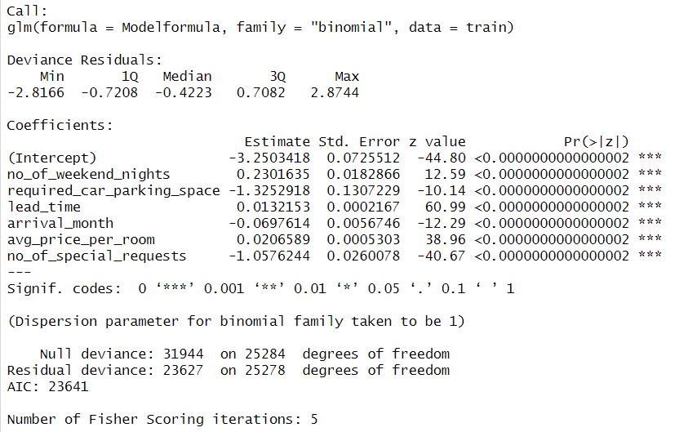
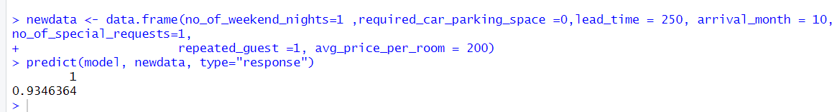
To find the overall predicted accuracy of our model I have used confusion matrix. It basically categorizes the predictions against the actual values.
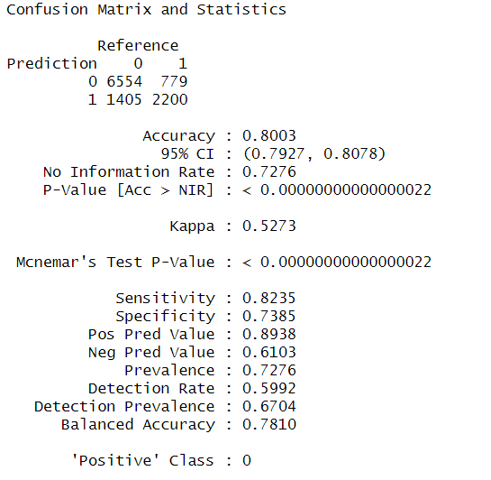
Sensitivity: The “true positive rate” – the percentage of individuals the model correctly predicted would default. Specificity: The “true negative rate” – the percentage of individuals the model correctly predicted would not default.
From Figure 2, we can find that Lead_time i.e., number of day between booking made and check-in date is by far the most important predictor variable, followed by no_of_special_request, average price per room, arrival month and then no_of_weekend_nights. It means chances of booking gets cancelled is high when lead time is more.
Figure 2
From above chart, we can compute higher lead time and higher price leads to more cancellation.
TABLE 1

> newdata <- data.frame(no_of_weekend_nights=1 ,required_car_parking_space =0,lead_time = 250, arrival_month = 10, no_of_special_requests=1,
+ repeated_guest =1, avg_price_per_room = 200)

> predict(model, newdata, type="response")
1
0.9385125
> predicted <- predict(model, test, type="response")
> predicted1<- ifelse(predicted>0.51, 1, 0)
> predicted<- ifelse(predicted>0.51, 1, 0)
>
> head(predicted)
4 6 7 15 17 18
1 1 0 0 0 0

> tail(predicted)
36265 36270 36271 36272 36273 36274
1 1 1 0 0 0

To predict hotel reservation being cancelled or not using model it gave result shown above.
After fitting logistic regression model, I have made the prediction for both reservations being cancelled or not. The first six and last six rows have been shown above. When probability threshold is kept at 0.51 it gives highest accuracy. And gives higher AUC = 0.72. High AUC indicates that our model does a good job of predicting whether customer will cancel reservation. ROC determines the accuracy of a classification model. ROC is plotted between True Positive Rate (Y axis) and False Positive Rate (X Axis).

CONCLUSION
We have been successfully able to visualize what factor leads to cancellation of booking and can predict whether hotel reservation will get cancelled or not using logistic regression model that predicts with an accuracy of 80.03%, overall, that is a good percentage which means it’s a good model for predicting cancellation. When we look at the correlation, we can see that there is not a significant correlation between our data. When we look at the exploratory analysis, we can see that there are some outliers, but they had no impact on the model's development. We can also see some interesting patterns in relation to reservations; in general, much of the data shows a pattern in reservations. The lead time variable is the most significant followed by average price per room because reservations with a high lead time are more likely to cancel. We also have other interesting insights, such as the fact that previous guests and visitors who make special requests or request a parking space are less likely to cancel.

REFERENCES
Lander, J. P. (2021). R For Everyone. Addison-Wesley.
Zach. “How to Interpret a ROC Curve (with Examples).” Statology, 9 Aug. 2021, www.statology.org/interpret-roc-curve/#:~:text=When%20we%20create%20a%20ROC%20curve%2C%20we%20plot.

